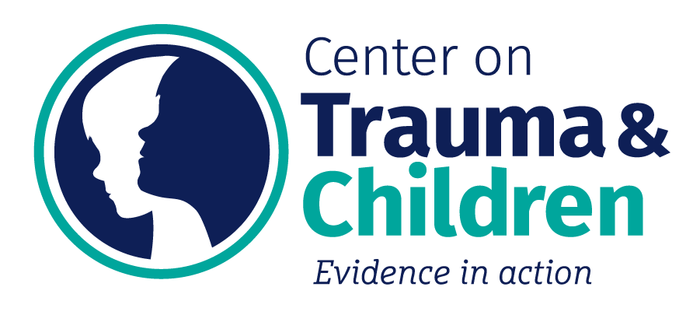

Child & Adolescent Trauma Treatment
& Training Institute (CATTTI)
REFERRAL FORM

Please completely fill out this form: missing information will delay processing of the referral. To complete, tab among fields, or click to type.

Referrals are accepted from caregivers and professionals.

Please keep the document in Microsoft Word format, save a copy to your computer, and then email the completed form to CATTTIReferrals@uky.edu. Please put UK CATTTI Referral in the subject line.

Date Submitted:
CHILD INFORMATION (one child per form)
Full Name (first, middle, last) |  |  |  |  | DOB |  | Age |  |  |  | SSN & Medicaid #
Race |  | Ethnicity |  |  | Biological Sex |  |  |  |  |  | Gender
Has this child received services from the CATTTI clinic previously? Yes No
REFERRAL SOURCE INFORMATION
Your Name |  |  |  |  |  | Relationship to Child
Email |  |  |  |  |  | Phone
Address |  |  |  |  |  | How did you learn about CATTTI?
Is this a court-ordered referral? |  |  | No Yes: by whom?  If yes, please include contact information for the court (name of contact and phone number)
What type of service are you referring this child for? |  |  | Trauma Assessment resulting in report with treatment recommendations  Trauma-Focused Treatment, including an assessment  Trauma-Informed Parenting Skills for Resource Parents (TIPS 4 RP)
3. CURRENT CAREGIVER INFORMATION (e.g. Who the child lives with - parent, relative, foster provider, etc.)
Caregiver Name |  |  |  |  |  | Relationship to Child
Email |  |  |  |  |  | Phone
Street Address |  |  |  |  |  | City, State, Zip Code
Who has legal custody of  the child? | Biological Parent Adoptive Parent Relative, specify relation:  State Other, specify:
Is the child’s caregiver aware of this referral? No Yes
4. DCBS INFORMATION
Does this child have a history of involvement with DCBS? No Yes

If yes, please provide a summary of involvement:
Does this child currently have an open case with DCBS? No Yes

If yes, is the DCBS worker aware of this referral? No Yes
DCBS Worker |  |  |  |  |  | Supervisor
Email |  |  |  |  |  | Phone
Fax |  |  |  |  |  | County
DCBS Case  ID Number |  |  |  |  |  | Is child placed in a concurrent home?
Has the goal been changed to adoption (or PPLA)? |  |  |  |  |  | Have parental rights been terminated?
5. MENTAL HEALTH/BEHAVIORAL HEALTH SERVICE PROVIDERS
Is the child currently receiving mental health treatment? No Yes |  |  |  | If yes, with whom & where:  If yes, is child’s therapist aware of this referral? No Yes
Is this child prescribed any medications for psychological/behavioral symptoms?  No Yes |  |  |  | If yes, please list medication(s):
6. CHILD’S HISTORY & FUNCTIONING
Has this child ever experienced or witnessed a potentially traumatic event, including but not limited to child abuse or interpersonal violence? No Yes
Please summarize the type(s) of traumatic event(s) the child experienced (e.g. physical abuse, neglect, car accident, natural disaster, etc.) and when they occurred:
Please describe any current symptoms and/or concerning behaviors displayed by this child:
Does this child have any developmental delays or other issues that may interfere with their ability to participate in trauma-focused treatment or assessment? No Yes
If yes, please explain:
Has this child been placed with anyone other than their biological parents? No Yes
If yes, please summarize placement history:
7. RISK
Does the child have a history of suicidal ideations (talked about wanting to die, kill self, etc.)?
No Yes – If yes, when was the most recent statement?
Does the child have a history of suicide attempts?
No Yes – If yes, when was the most recent attempt? Please describe nature and severity.
Does the child have a history of hurting self or others?
No Yes – If yes, please explain:
Is the child currently at risk of harming self or others?
No Yes – If yes, please explain:
Does this child have a history of substance use?
No Yes – If yes, please describe:
Does the child have current substance use?
No Yes – If yes, please describe:
8. ASSESSMENT QUESTIONS / TREATMENT CONCERNS
What emotional and/or behavioral concerns would you like addressed?
1.
2.
3.
Once we receive your referral we will confirm receipt and follow up with any additional questions or concerns. If you have further questions about our referral process or the types of services we provide, please visit our website at www.uky.edu/CTAC/CATTTI or call 859-218-6956.

Thank you!

